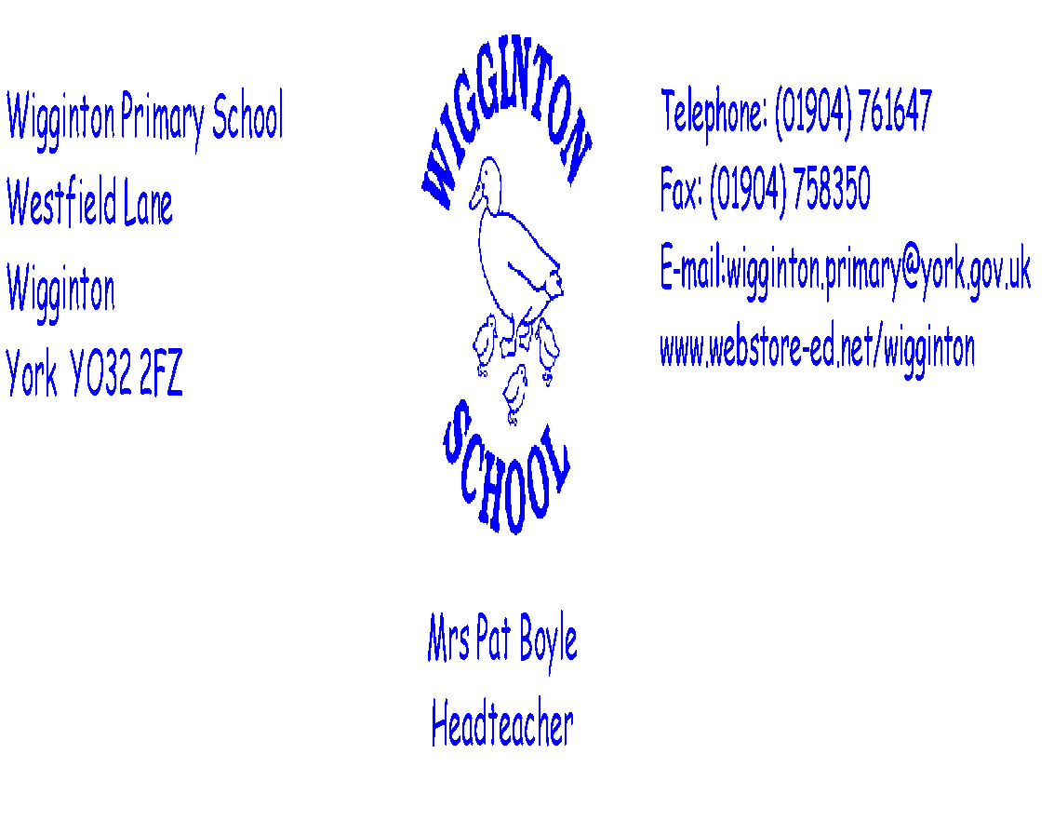
Wigginton Primary School

Charging and Remissions Policy

AIMS OF THE POLICY
Wigginton Primary School believes that all our pupils should have an equal opportunity to benefit from school activities and visits (curricular and extracurricular) independently of their parents/carers financial means. This charging and remissions policy describes how we will do our best to ensure a good range of visits and activities is offered and, at the same time, try to minimise the financial barriers which may otherwise prevent some pupils taking full advantage of the opportunities.

BACKGROUND TO THE POLICY
Sections 449 to 462 of the Education Act (1996) requires all schools to have a policy on charging and remissions for school activities. This legislation may be viewed at http://www.opsi.gov.uk/acts/acts1996/ukpga_19960056_en_28

Voluntary Contributions
As a school, we seek to keep costs to a minimum. Charges made will not exceed the actual costs. Where possible, we will look for alternative forms of funding. Where necessary, we will ask for voluntary contributions towards the cost of:
- School trips
- Visitors into school
- Swimming
- Any activity that takes place within school hours that incurs a cost eg: baking

These contributions are genuinely voluntary and any pupil of parents who are unable or unwilling to contribute will not be discriminated against. Where there are too few voluntary contributions to make the activity possible and there is no way to make up the shortfall, then the activity will be cancelled. Families in receipt of income related benefits i.e. Free School Meals will not be asked for a voluntary contribution.

The PTA
The PTA supports the school by making an annual donation towards the costs of school trips. The school ensures that every child receives the same level of subsidy. The PTA also funds school Christmas parties, visiting theatre productions at Christmas etc.

Residential Trips
Charges will be made for the cost of the visit (board and lodging, travel costs, entrance fees etc). Families are invited to pay in instalments over several months or in one single payment. Where the trip takes place wholly, or mainly, during school hours children who are eligible for Free School Meals will not be charged for the cost of board and lodging during the residential trip.

All subsidies come from the school budget. These costs are not passed on to other pupils. Any parent/carer who refuses or is unable to meet the charge should not expect their child to be included. In cases where the specific circumstances, often temporary, of a particular family’s hardship fall outside these criteria, the Headteacher may use their discretion to remit charges in part or in full. Any parent/carer unable to meet the cost is invited to apply for a remission. A form is attached (Appendix A).

Swimming
The costs of providing swimming tuition in the local public pools, including transport, hire of the pool and provision of instructors, will be reviewed on an annual basis. Although the school will provide some funds to support this activity to ensure all pupils’ educational requirements for swimming will be met, it will be necessary to request voluntary contributions to offset the balance of costs.

Musical Instrument Tuition
All pupils study music as part of the normal school curriculum for which no charge is made. School staff may also run after school or lunchtime groups for which there may be a charge.

Parents can request tuition for individuals, or small groups of up to four pupils, to play a musical instrument. Tutors make a charge for that tuition. Details are available from the school office but parents deal directly with the service.

Under ‘The Wider Opportunities’ programme, the school provides free viola and cello lessons for Y5 and Y6 pupils.

Milk
All children are offered milk as a mid-morning drink. It is provided free for children up to the age of 5. It is charged at cost for children over 5. Children entitled to FSM continue to receive it free of charge.

Information requests in line with Freedom of Information Act
Charges are listed as part of the school’s published scheme. Initial copies must be provided for free. Additional photocopies will be charged at the rate of copy costs (1p per black and white copy, 5p per colour copy).

Extra Curricular Clubs.
Clubs are run by a mixture of staff, coaches, parents, volunteers and private providers. Staff make no charges for their time. Other providers may charge and these costs are made clear at the outset.

Other Charges

Lost or Damaged Items of School Property
Parents/carers may be asked to make a contribution towards replacing damaged school property caused wilfully or negligently by their child/ren. This may include window breakage and removal of graffiti. A charge to cover the cost of replacement may also be made for lost or damaged items of school property, including library books/text books.

School Uniform
Wigginton School uses a clothing supplier who provides quality schoolwear at affordable prices.

School Meals
Parents/carers whose child takes a school lunch must pay the relevant cost stated by the schools catering supplier. Reception and Key Stage One pupils are currently provided meals at no cost. Pupils may be eligible for free schools meals. Application forms are available from the school office.

This policy has been agreed by the Governors and is reviewed annually.

Signed ____________________________ (Chair of Governors)

Signed ____________________________ (Headteacher)

Appendix A

Application for remission of charges
To apply for a remission of a charge a parent/carer should complete this form with the following information.

Family name of Parent/Carer |  |  |  |  |  |  |  |  | Mr/Mrs/Miss/Ms/Dr/
Forename/s |  |  |  |  |  |  | Relationship to pupil
Full Postal Address
Postcode |  |  |  | Phone No. |  |  |  | Mobile No.

Please give details below of each dependant child who is in full-time attendance at the school for whom you wish to apply for remission.

Full Names of Child/ren | M/F | Date/s of birth | Class/es

Name of Activity |  | Date of Activity
Please state the reason(s) why you are requesting remission:

I wish to apply for remission of charges for the educational activity detailed above

Signature of Applicant …………………………………… Date …………….

Please return the completed form to the school office in an envelope addressed to the Headteacher and marked confidential.

For School use only
Remission Approved |  | Yes / No | Reason
Signed by |  |  | Reason
Position |  |  | Reason
Date |  |  | Reason

