Objective | Concrete | Pictorial | Abstract
I can add numbers with more than 4 digits using written methods. | 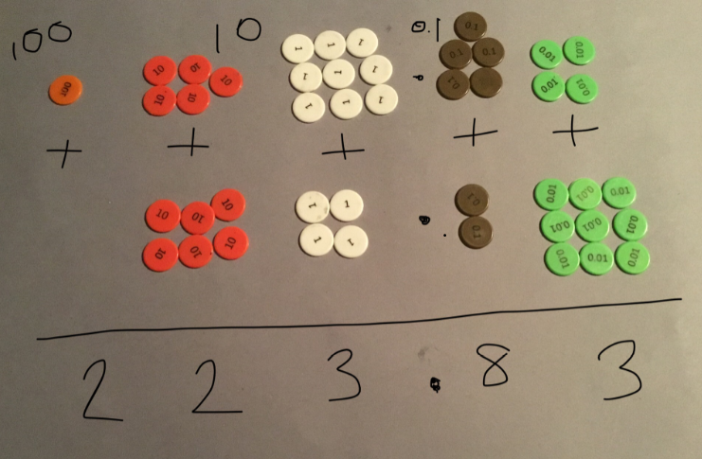 | 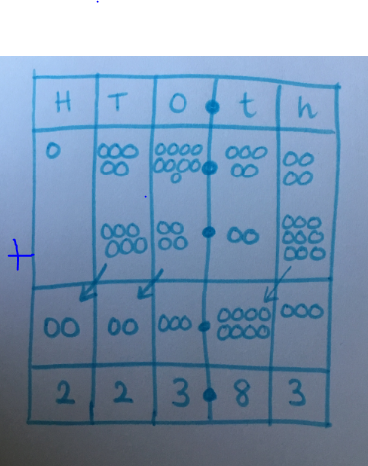 | 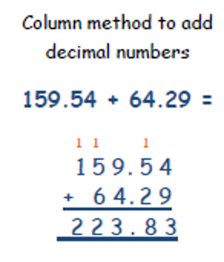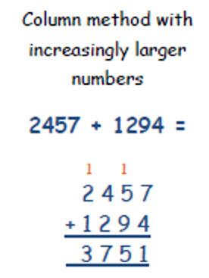  Then larger numbers and numbers with mixed whole places or mixed decimal places.
I can subtract numbers with more than 4 digits using written methods. | 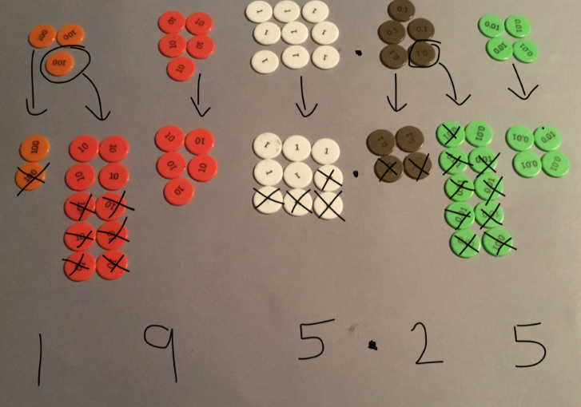 | 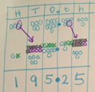 | 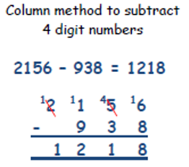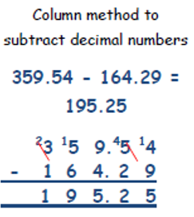  Then larger numbers and numbers with mixed whole places or mixed decimal places.
I can multiply multi-digit numbers up to 4 digits by a 2-digit whole number using a written method. | 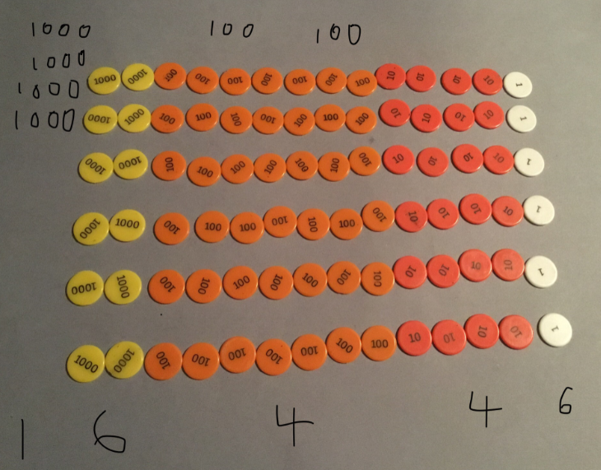 | 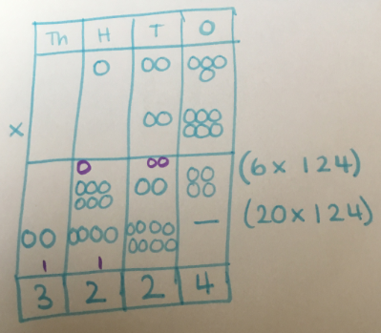 | 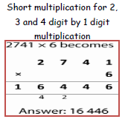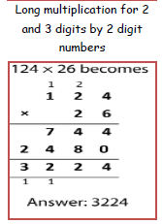  NB. Some pupils will need to continue to work with an expanded version of this method.
I can divide numbers up to 4 digits by a 2-digit whole number using a written method. | 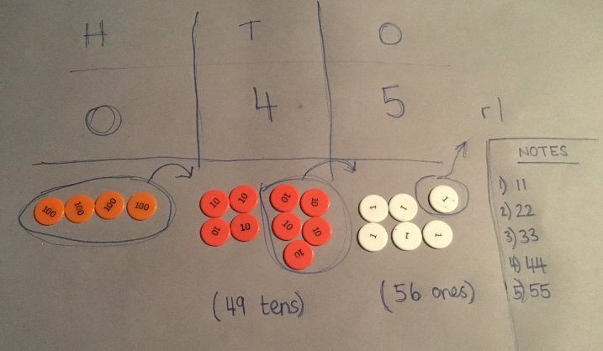 | 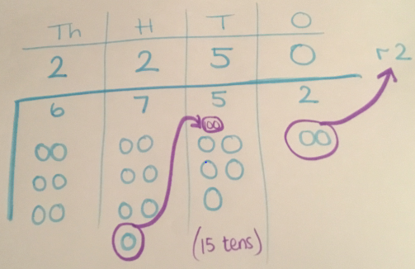 | 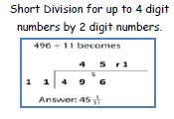  NB. Pupils may need to make informal notes to support them working with multiples of 2-digit numbers.

