Objective | Concrete | Pictorial | Abstract
Recognise the place value of each digit in any number up to 1,000,000 | As earlier work with larger numbers. Emphasis to be placed on alternative ways of partitioning (e.g. 38,593 = 38 thousands, 59 tens and 3 ones). NB. Clear commas to be inserted in much larger numbers as this enables pupils to read more complex numbers more easily.
I can add numbers with more than 4 digits using written methods. | 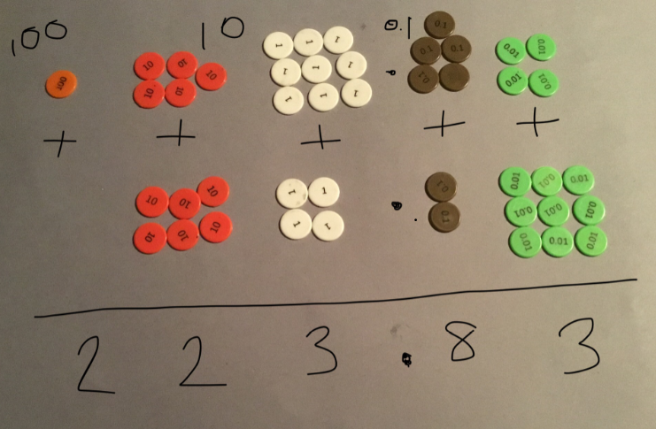 | 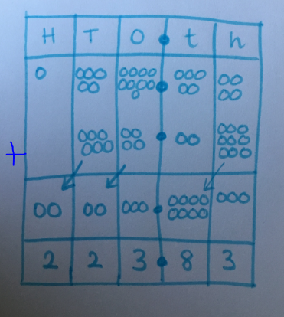 | 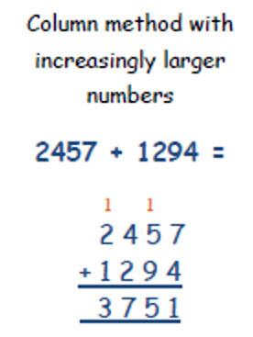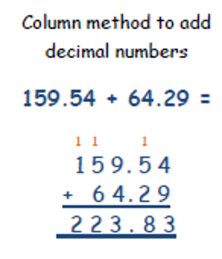
I can subtract numbers with more than 4 digits using written methods. | 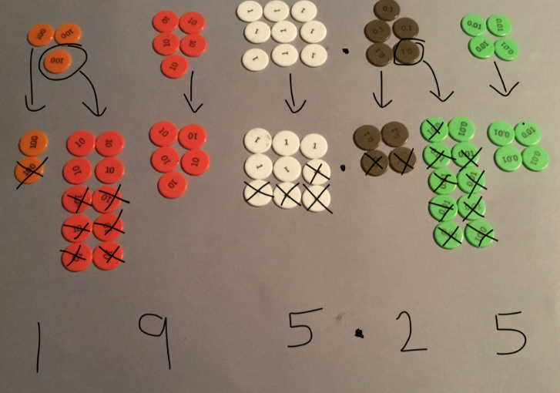 | 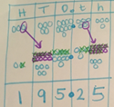 | 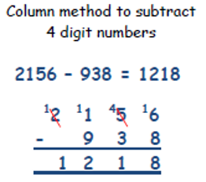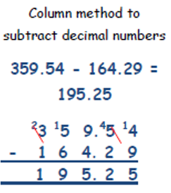
I can x numbers up to 4 digits by a 1 digit number using a written method. | 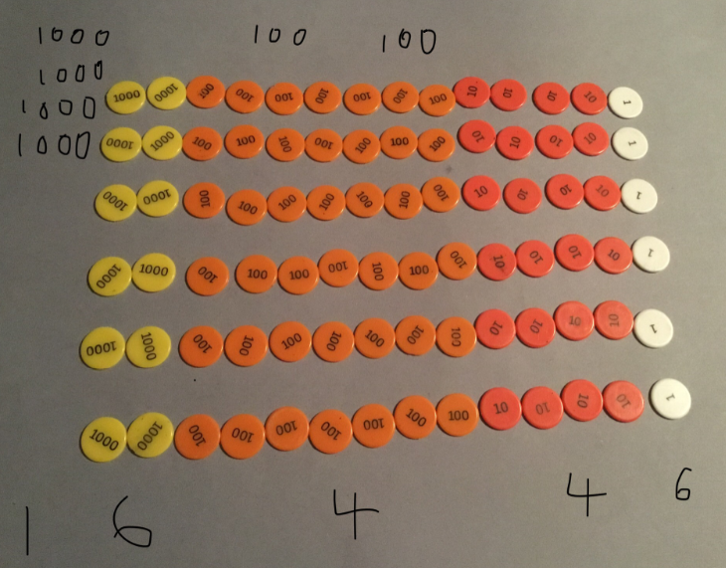 | 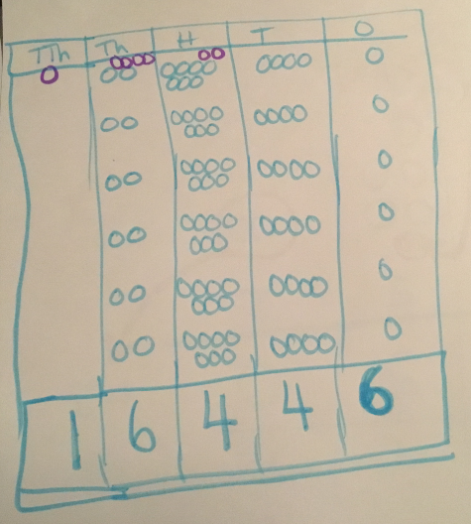 | 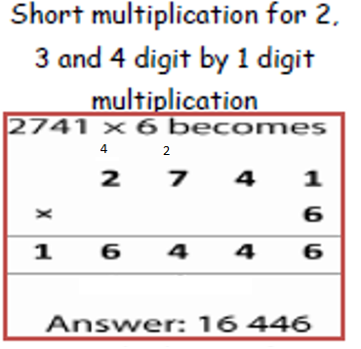
I can divide numbers up to 4 digits by a 1-digit number using a written method. | 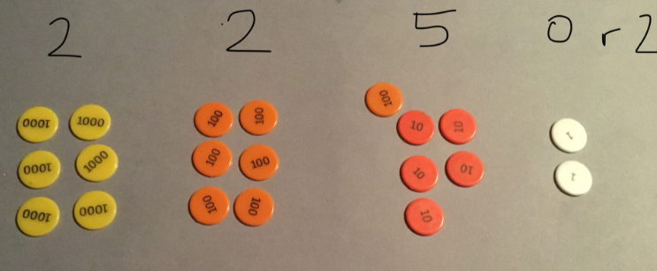 | 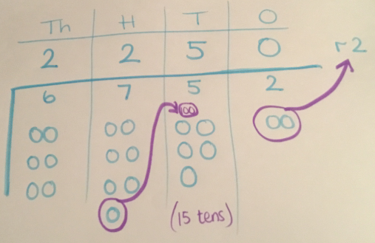 | 

