Objective | Concrete | Pictorial | Abstract
Recognise the place value of each digit in a 4-digit number | 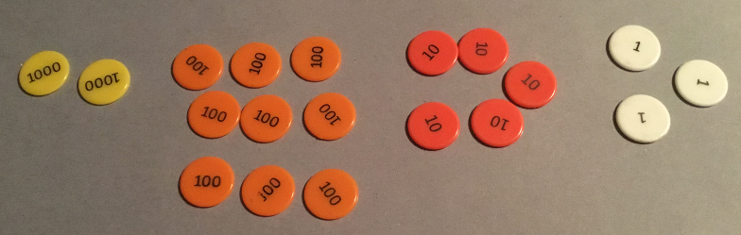 | 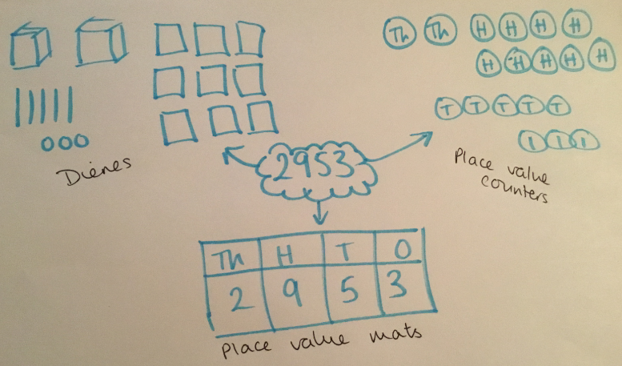 | 2953 = 2000 + 900 + 50 + 3 or 2953 = 2 thousands, 9 hundreds, 5 tens and 3 ones  Consider alternative ways of partitioning (e.g. 29 hundreds + 53 ones)
I can add numbers with up to 4-digits using a written method. | 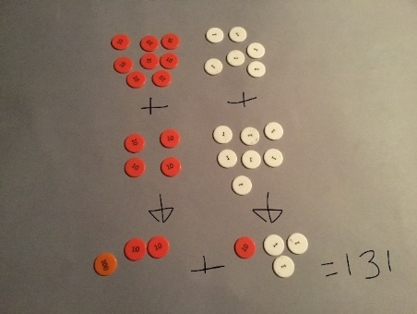 | 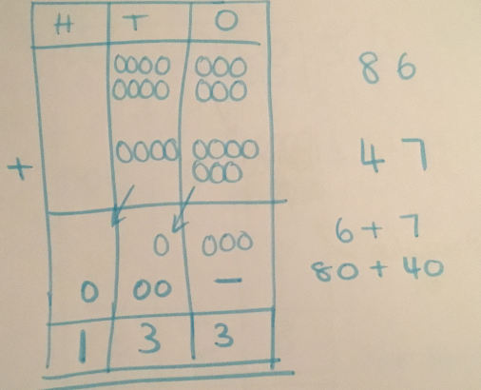 | 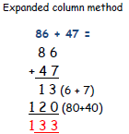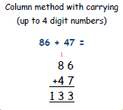
I can subtract numbers with up to 4-digits using a written method. | 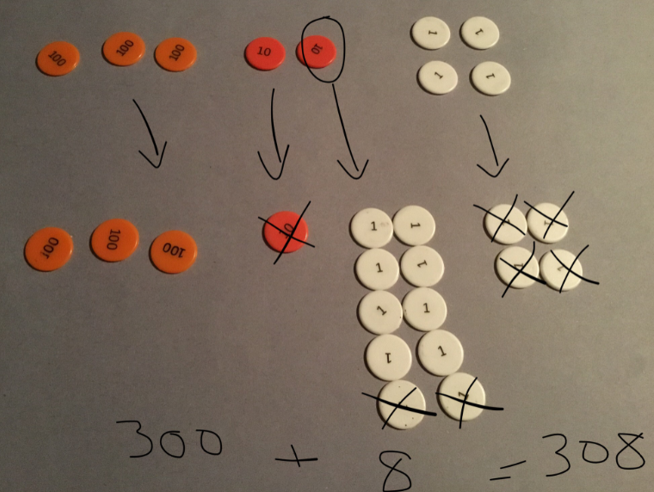 | 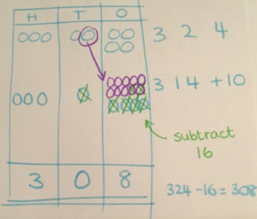 | 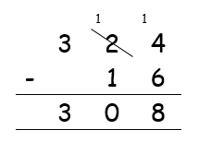
I can use efficient written methods to times a 2-digit and 1-digit number. | 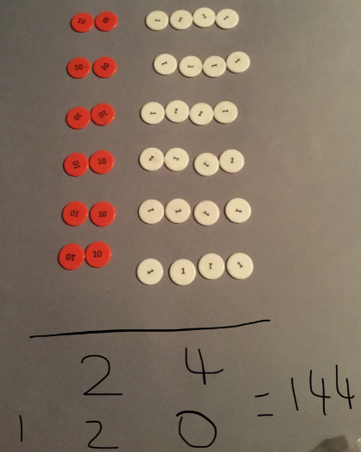 | 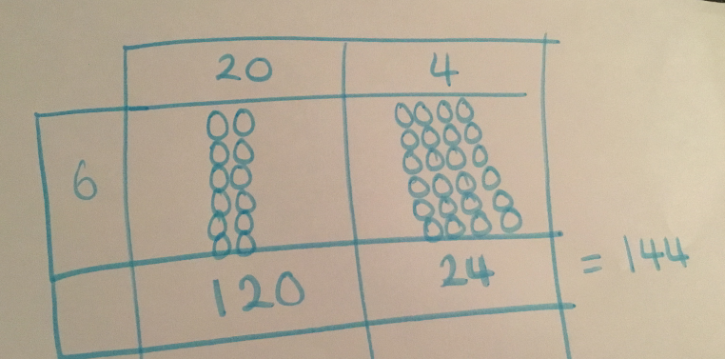 | 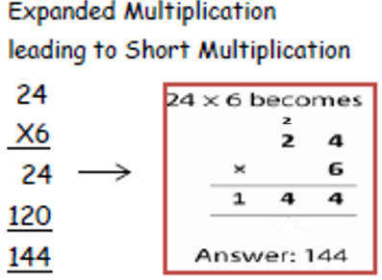
I can use efficient written methods to divide a 3-digit and 1-digit number. | 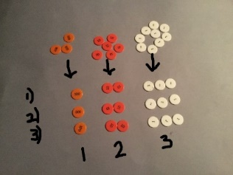 | 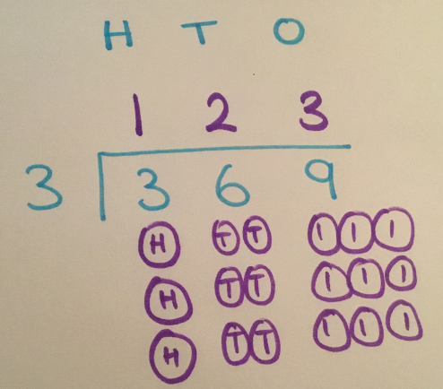 | 

