Objective | Concrete | Pictorial | Abstract
Recognise the place value of each digit in a 3-digit number | 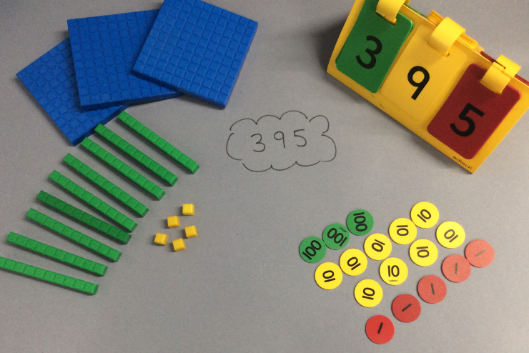 | 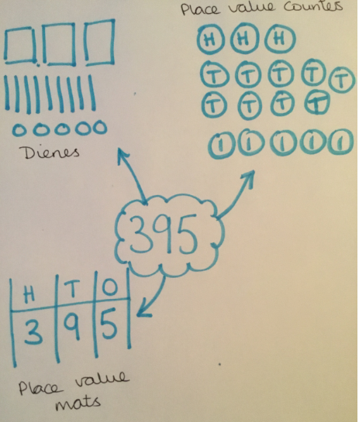 | 395 = 300 + 90 + 5 or 395 = 3 hundreds, 9 tens and 5 ones
I can find 10 or 100 more or less of any given number. | 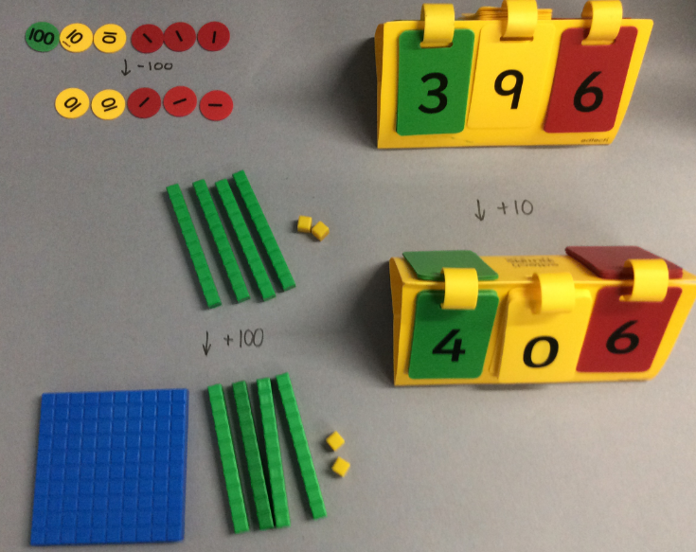 | 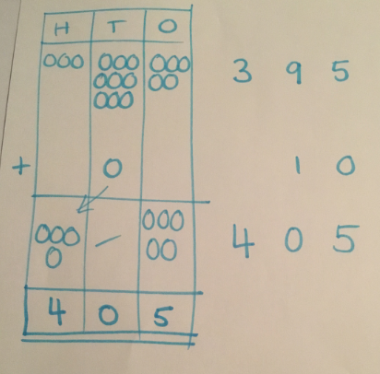 | 395 + 10 = 405  408 – 10 = 398 etc
I can add and subtract numbers mentally (3-digit number & H/T/O). | 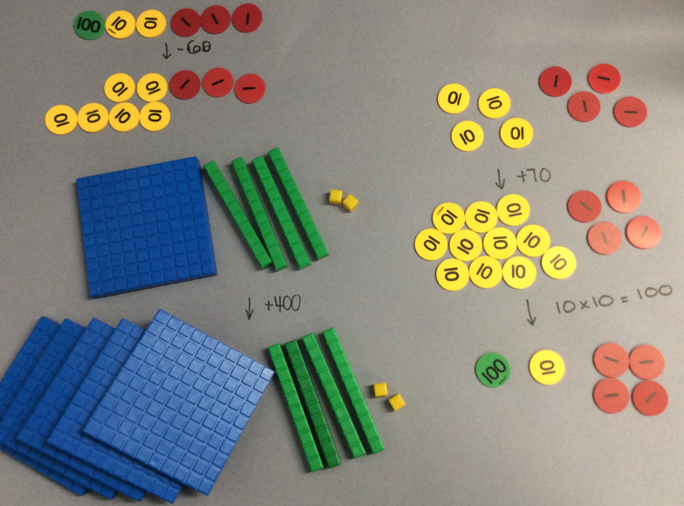 | 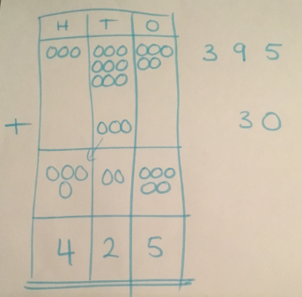 | 439 + 5 = 444  395 + 30 = 425  402 + 500 = 902
I can add numbers with up to 3-digits using a written method. | 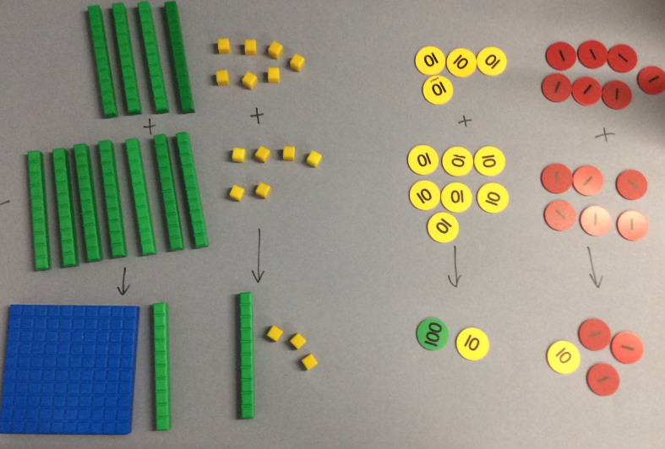 | 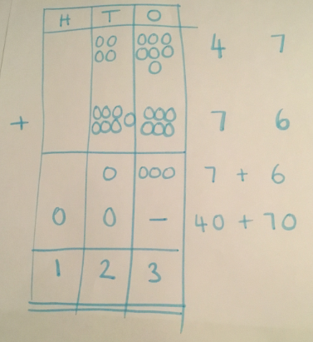 | 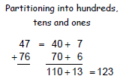then…  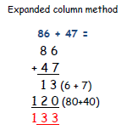
I can subtract numbers with up to 3-digits using a written method. | 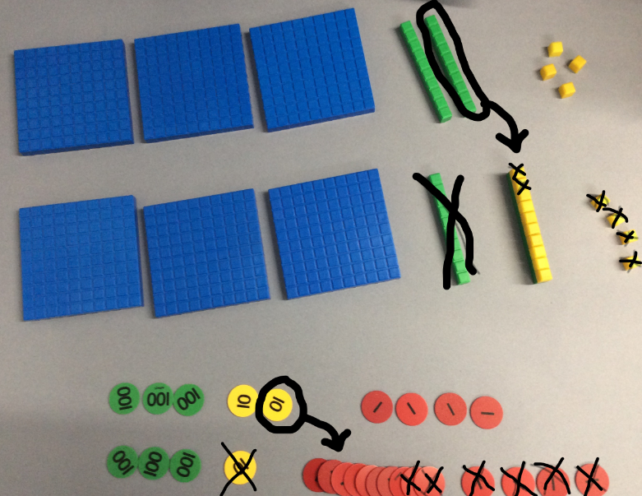 | 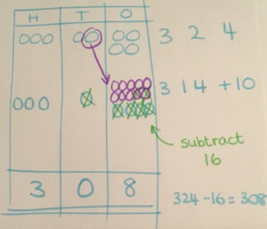 | 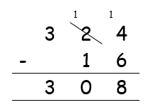
I can use efficient written methods to times a 2-digit and 1-digit number. | 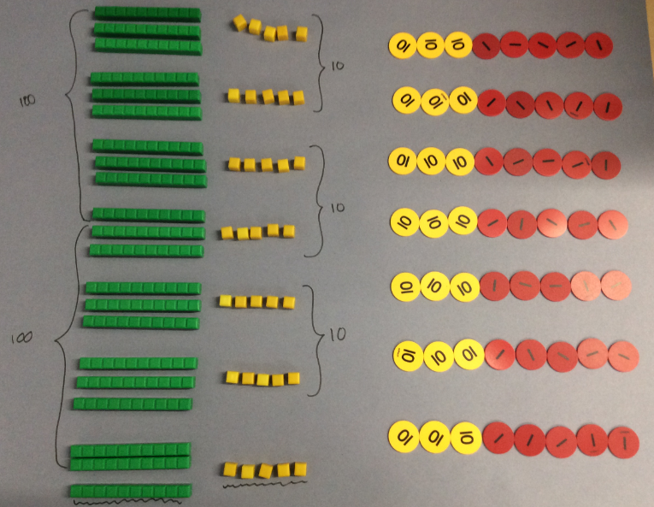 | 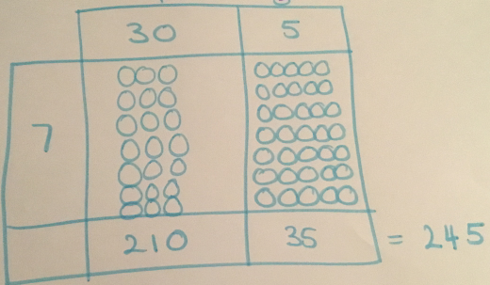 | 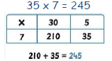
I can use efficient written methods to divide a 2-digit number and 1-digit number | Chunking with equipment:  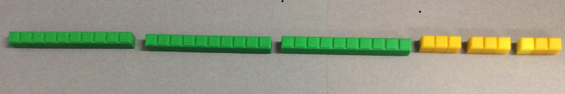  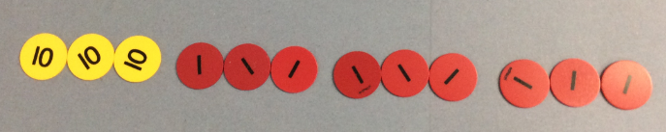 | 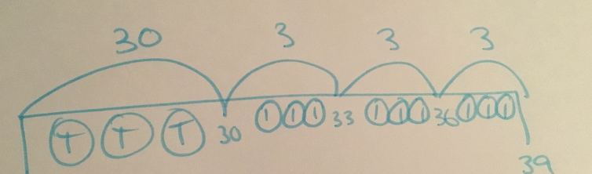 | 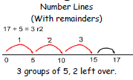then…  

