Objective | Concrete | Pictorial | Abstract
I know the place value of each digit in a 2-digit number | 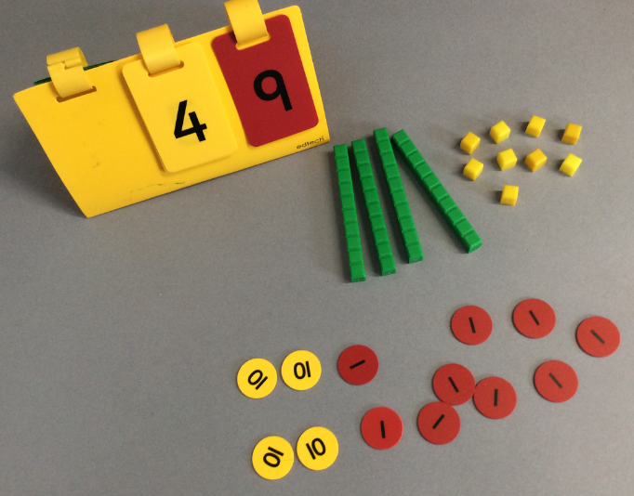 | 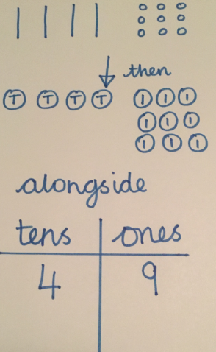 | 49 = 40 + 9 or 49 = 4 tens and 9 ones
I can identify, represent and estimate numbers | 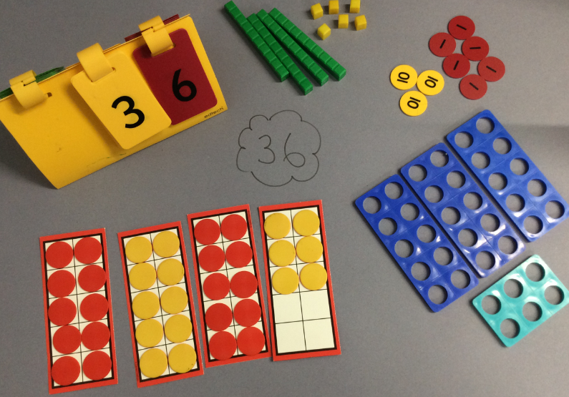 | 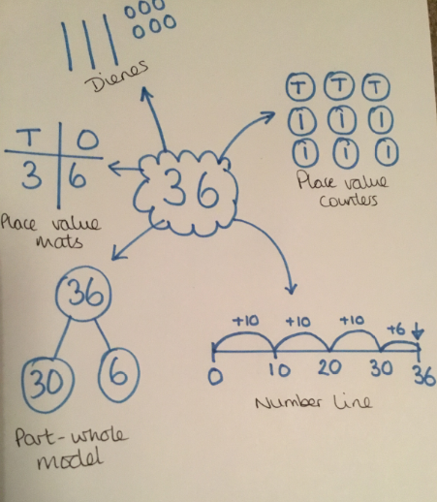 | How many ways can you show the number 36?
I can recall and use + and – facts to 20 and use number facts to 100 | 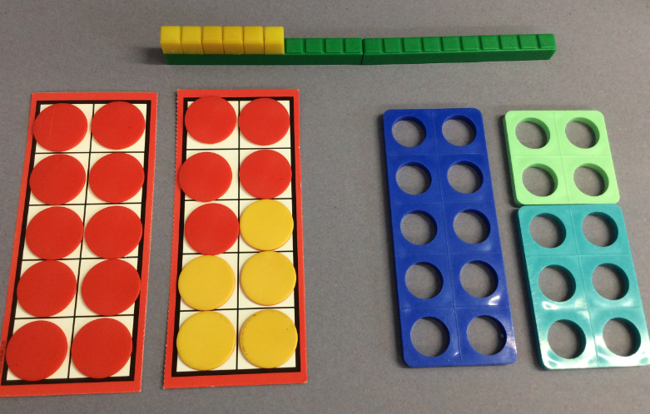 | 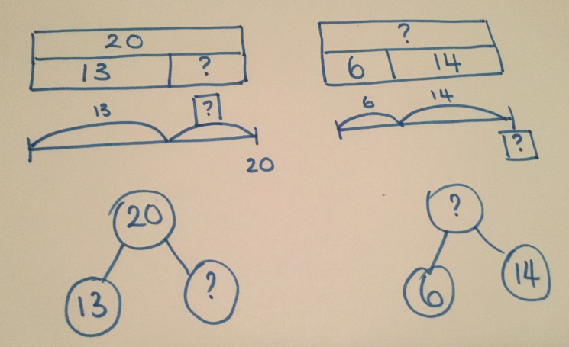 | 13 + ___ = 20  15 - ___ = 2  NB. It is important that children explore bonds to more numbers than just 10, 20 and 100 at this stage, securing their understanding of number.
I can add and subtract using equipment, pictures and mentally | 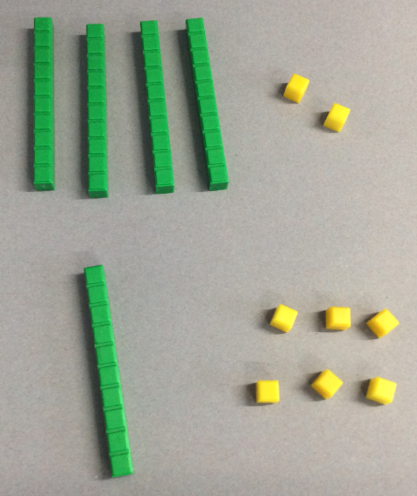 | 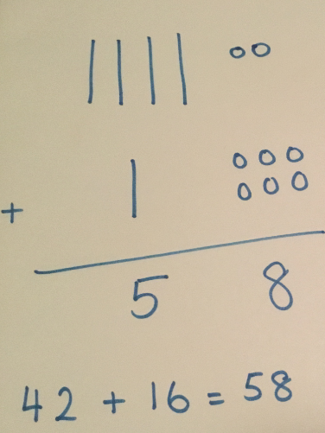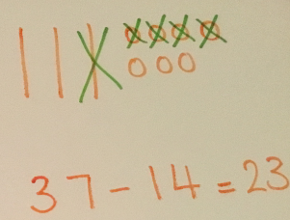 | 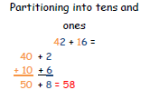
I can recall and use x facts for 2, 5 and 10 x tables | 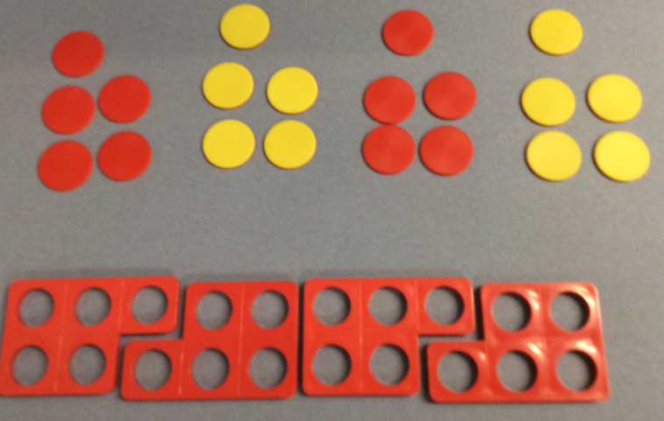 GD: 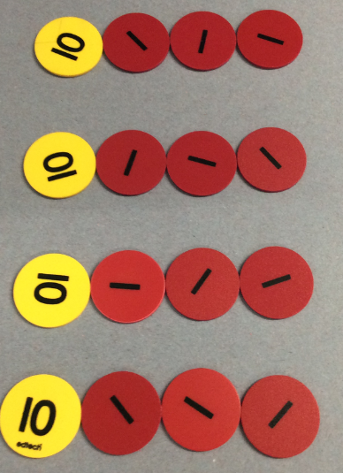 | 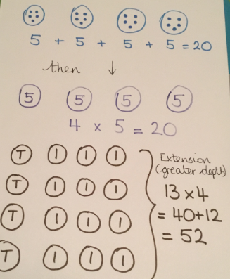 | 4 x 5 = ?
I can recall and use ÷ facts for 2, 5 and 10 x tables | 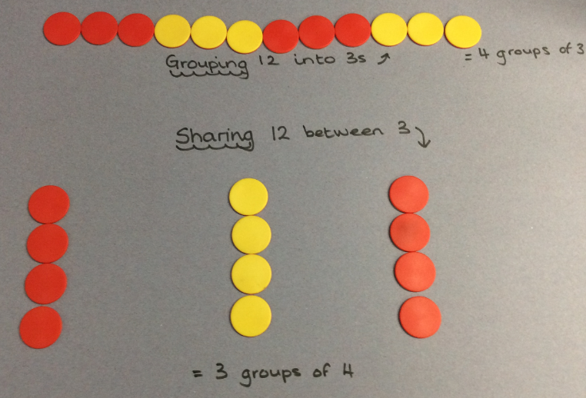 | 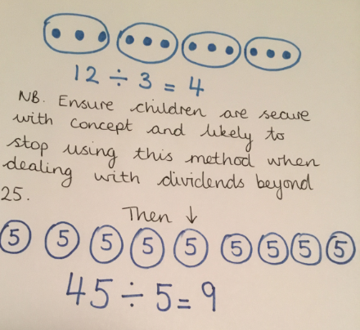 | 45 ÷ 5 = ?

