Objective | Concrete | Pictorial | Abstract
I can count to and across 100, forwards and backwards | 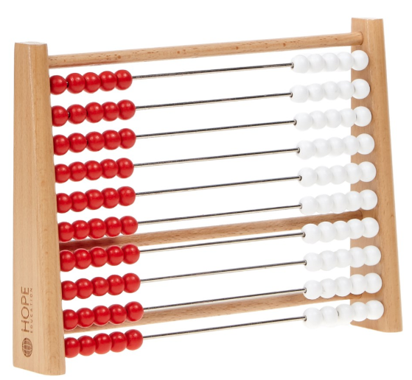 | 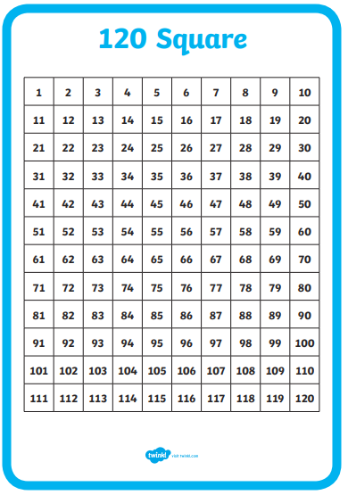 | Orally recite numbers in order, bridging forwards and backwards over tens or a hundred
I can read and write numbers to 100. | 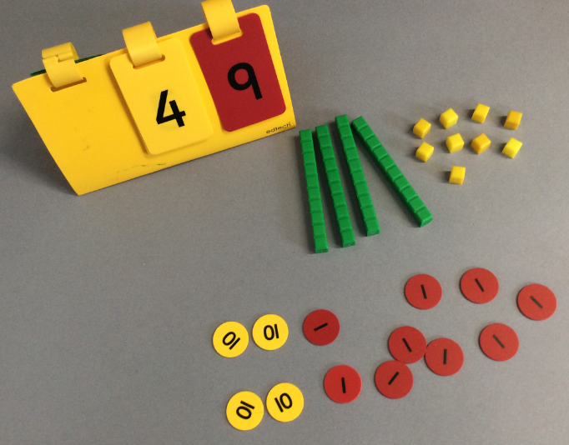 | 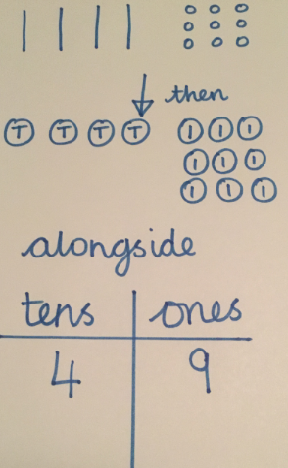 | Children can write all numerals to 100 accurately.  Note that there should be no numeral reversal by this stage
I can count forwards in multiples of 2 from any number. | 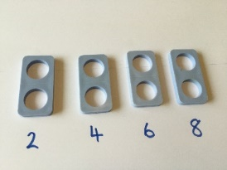 | 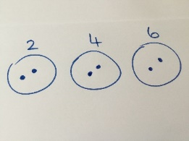 | 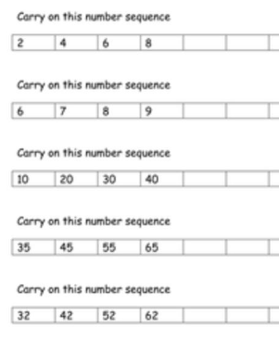
I can count forwards in multiples of 5 from any number. | 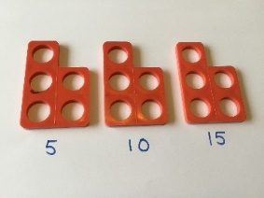 | 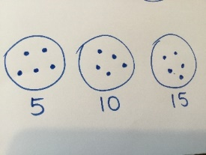
I can count forwards in multiples of 10 from any number. | 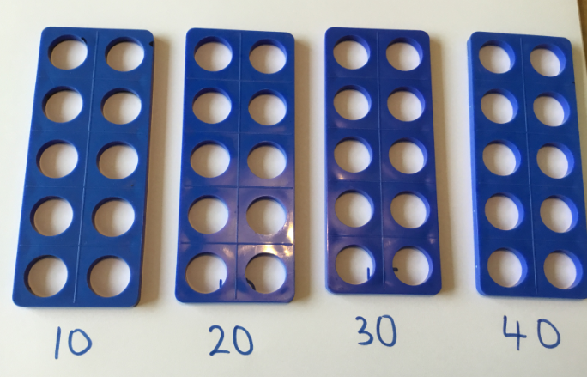 or 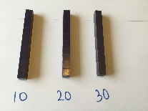 | 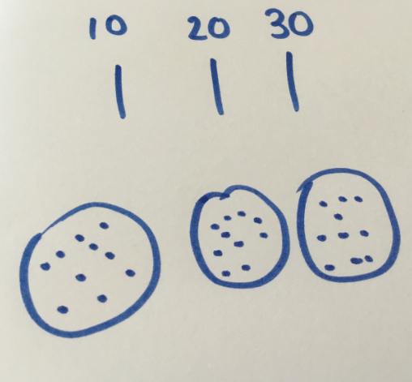
I can show and use subtraction facts to 20;  I can add and subtract 1-digit numbers to 20. | 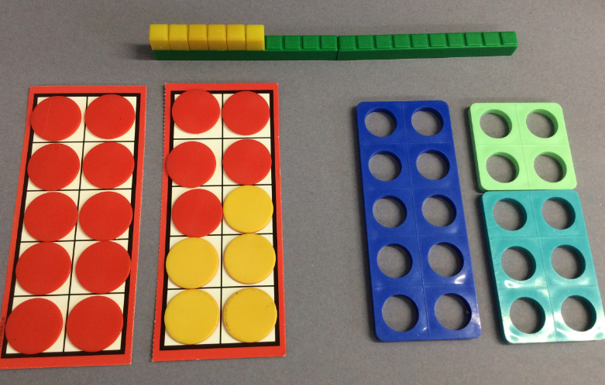 | 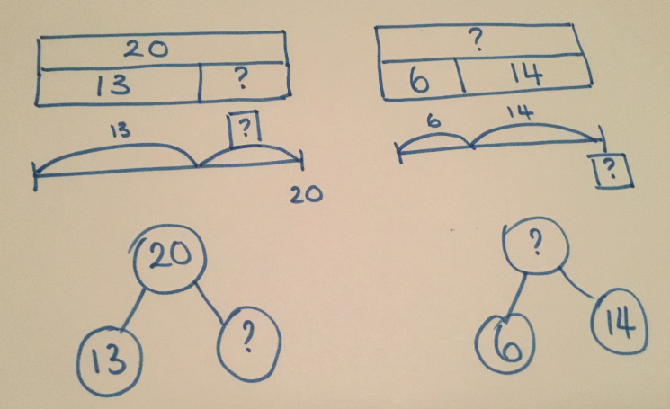 | 13 + ___ = 20  15 - ___ = 2  NB. It is important that children explore bonds to more numbers than just 10 and 20 e.g. bonds to 7 or 15 to help them to secure their sense of number.
I can find one more and one less than a given number within 100. | 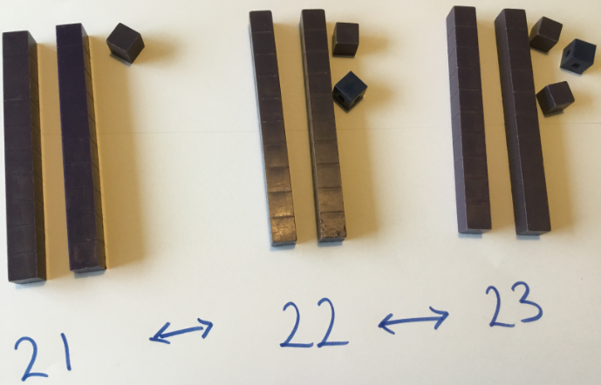 |  | 

